ØØ Explanation :
- Consider that two words are available in register pairs HL and DE. We have to add these two words.
- Using add instruction, add the contents, of the lower two bits i.e. add L and E.
- The result of this addition is stored in the A register.
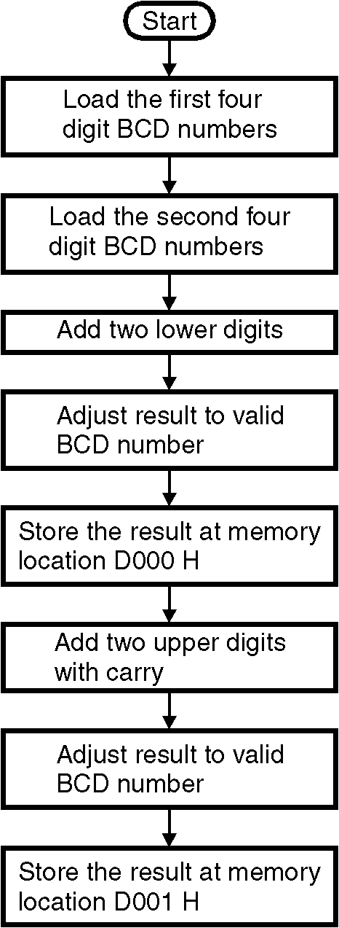
- DAA instruction is then used to convert the result to valid BCD. Store the result at memory location D000 H.
- Now, add the contents of MSB alongwith carry if generated in LSB addition.
- The result of MSB addition is stored in the A register. Adjust this result to valid BCD number. The final result is then stored at the memory location D001 H.
e.g. : HL = 3629 BCD
DE = 4738 BCD
Step I : |  | 2 | 9
 | + | 3 | 8
 |  | 6 | 1 | and auxiliary carry = 1
As AC = 1, add 6 to make result valid.
61 + 6 = 67
Step II : 36 + 47 + 0 (Carry of LSB) = 7 D.
Lower nibble of addition is greater than 9, so add 6.
 |  | 7 | D
 | + | 0 | 6
 |  | 8 | 3
Final result : 8367 BCD.
ØØ Algorithm :
Step I : Add two lower digits.
Step II : Adjust result to valid BCD number.
Step III : Store the result at memory location D000 H. Flowchart 14
Step IV : Add the two upper digits with carry.
Step V : Adjust result to valid BCD number.
Step VI : Store the result at memory location D001 H.
Step VII : Display the result.
Step VIII : Stop.
ØØ Flowchart : Refer flowchart 14.
ØØ Program :
Instruction Comment
MOV A, L ; Get the LSB of first number in A
ADD E ; A = A +E i.e. compute the LSB addition
DAA ; Convert the HEX to valid BCD result.
STA D000 H ; Store result of LSB addition at location D000 H
MOV H, A ; Get the MSB of first number in A
ADC D ; A = A +D + CY i.e. compute the MSB addition
DAA ; Convert the HEX to valid BCD result.
STA D001 H ; Store result of LSB addition at location D001 H
HLT ; Terminate the execution of program

